MODULE 1 – AT THE SUPERMARKET
TASKSHEET 1
Complete the table. List various foods or products for each of the section of the supermarket.
Fruit
Vegetables
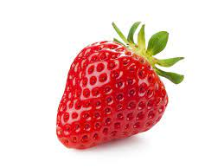
Dairy Products
Personal care products
Bakery
Poultry
Meat
Seafood

