Culinary Vocabulary Mastery:
Fill in the Blanks

Instructions:
📖 Read the passage carefully, paying attention to the context in which the words are used.
🕵️ Identify the gaps in the passage where a culinary term is missing.
📝 Select the appropriate word from the vocabulary list to fill in each blank space.
✅ Ensure that the chosen words fit seamlessly into the context of the passage, considering both grammatical and semantic appropriateness.

Use these words:
Dishes, nuances, ingredients, marinating, oven, finesse, buds

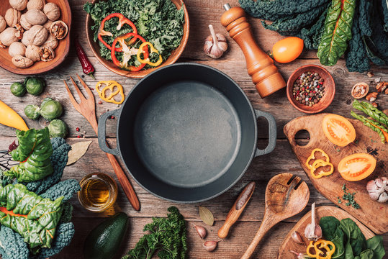
Cooking is a creative process, blending techniques and skills to craft delicious _______. To succeed, one must grasp the ________ of various ingredients. Let's explore the steps in preparing a mouthwatering meal.
Start with high-quality ______ like fresh vegetables and choice cuts of meat. Prepare them by chopping, slicing, or dicing for optimal taste. Add finesse by _______ or seasoning, letting the flavors meld.
Preheat the ______ for even cooking, ensuring the dish reaches its full potential. Alternatively, grilling offers a unique smoky flavor, complemented by a special garnish for added _______.
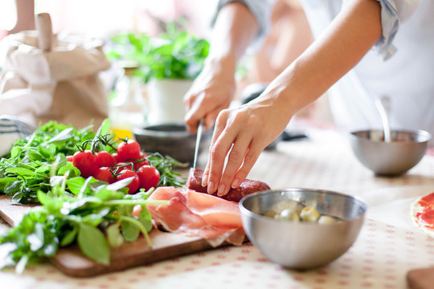
Presentation matters — a well-plated dish captivates visually. Use fresh herbs or edible flowers for a pop of color and heightened appeal.
Lastly, simmering sauces or broths melds flavors, creating a nuanced taste that delights your taste _____. In cooking, balance flavors, prioritize presentation, and embrace culinary finesse for a masterpiece!

