(School building, Technical, Financial)
17 Environmental Indicators
1. Percentage of children going to school by public transport, bicycle, car, legs. 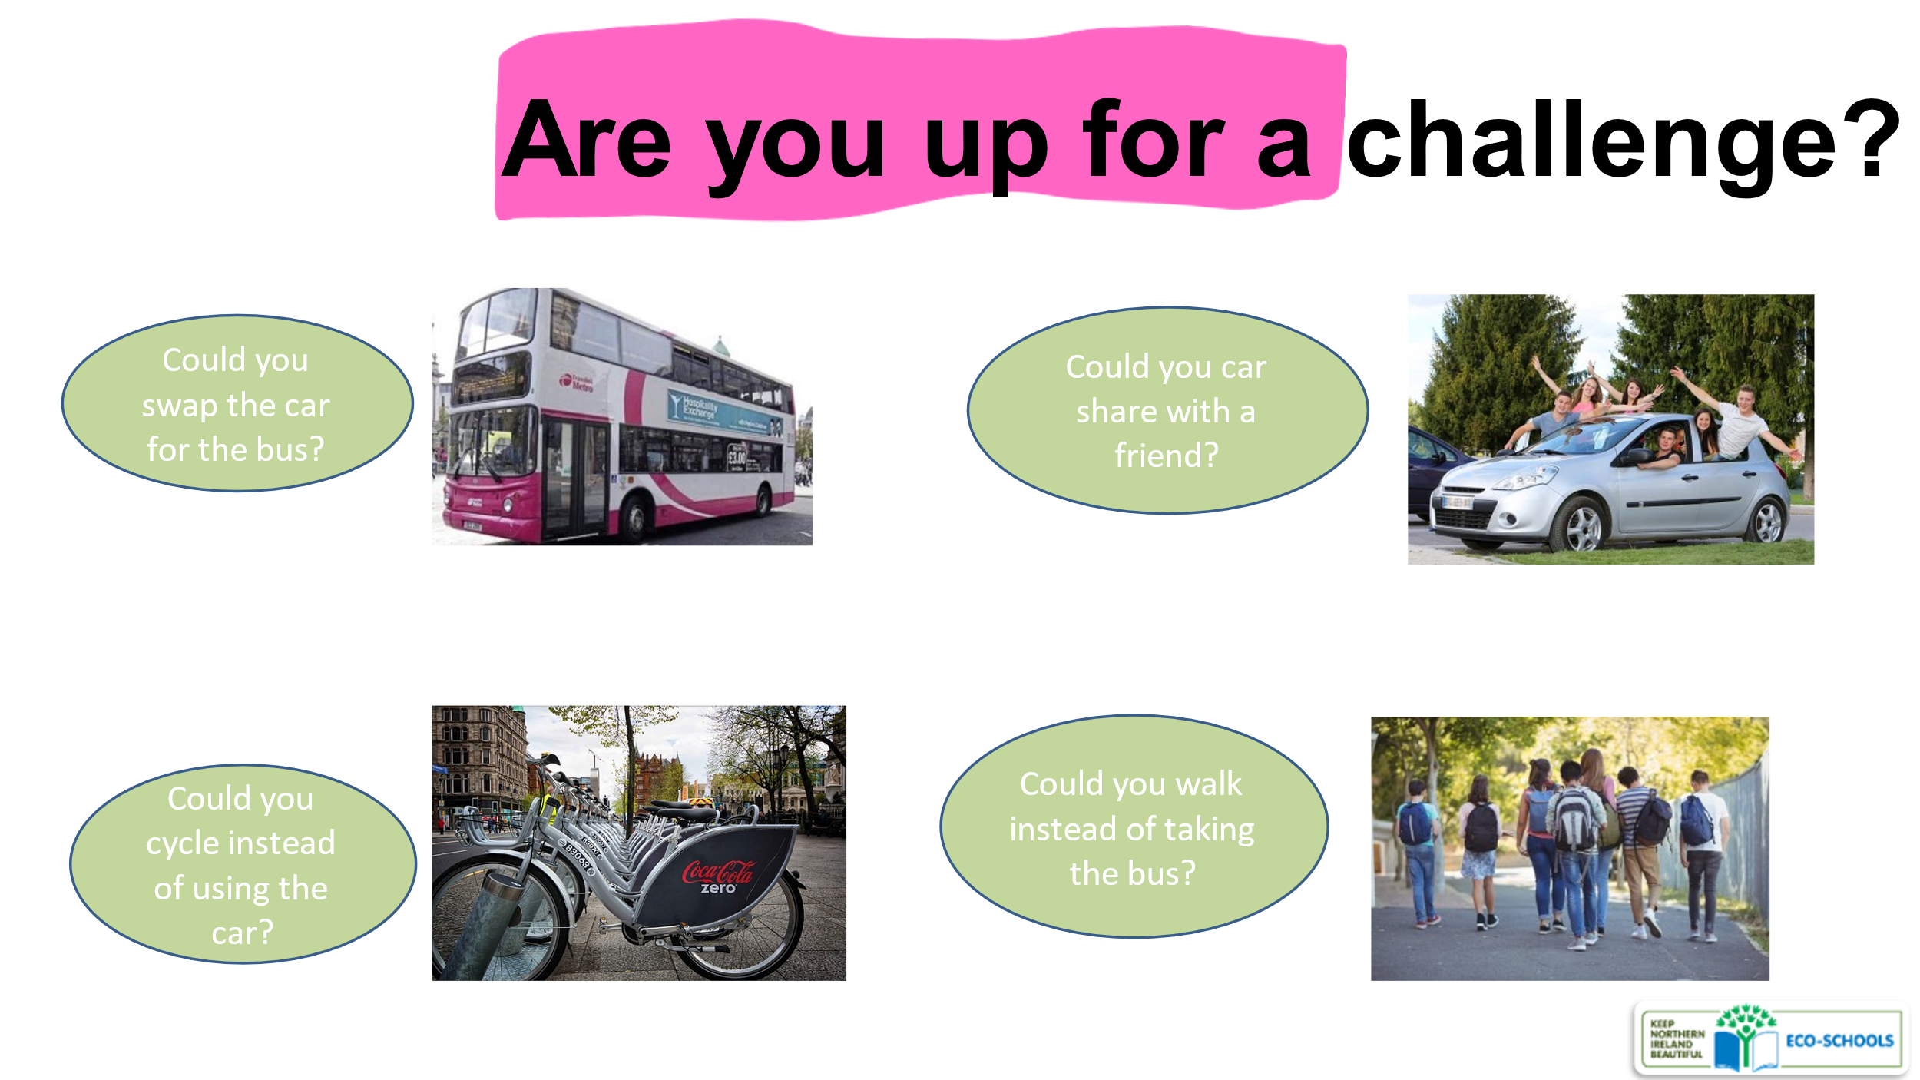
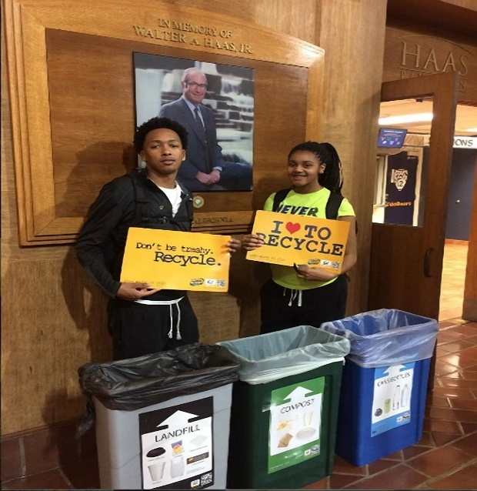
2. Weight of recyclable materials (paper, glass, metals, plastic) even given for recycling per student. (Figure 1)
Figure 1: StopWaste Project, New York
3. Waste weight that goes to the landfill, per student and teacher.
4. Consumption of electricity in Kilowatt Hours (Kwh) per student and teacher.
5. Water consumption in cubic meters of water per student and teacher.(Figure 2)
6. Is there a system for storing and utilizing rainwater? (Video on SydneyWaterTV) https://youtu.be/cwDgb72Mmd0
7. Number of sheets of photocopy paper per student and teacher.
Figure 2: Measuring water wasted in a minute from a leaking tap, Saint Mary’s North Primary School, Australia
«For comparison, providing each child in the US with a $100 laptop (recently available on the market) would cost about 8 billion dollars assuming even the little kindergarten children get one. In other words, we could pay for a laptop per child in the US in 4 years by stopping using paper in schools. Oh and that laptop can also replace the paper…»
Paper use in schools – The Reflective Educator (davidwees.com)
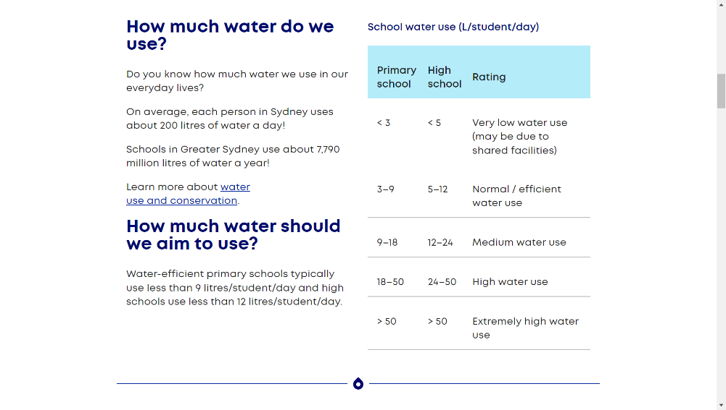
8. Are ecological detergents used for school cleaning?
9. Pounds per student of batteries, lamps and electrical-electronic devices given for recycling.
10. Is there a certificate for the maintenance of the radiator boiler this year?
Figure 3: From the Water Audit,
11. Consumption of oil (in liters) or natural gas for heating per student and educator.
12. Does the school building have thermal insulation (double glazing etc.)?
13. Power of photovoltaic systems available to the school.(Figure 4)
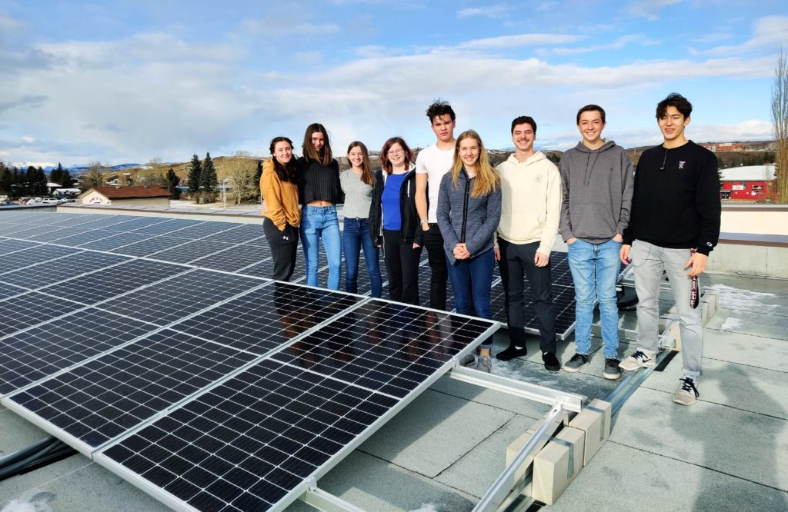
Figure 4 :Students from Cochrane High School with their solar PV array.
Photo credit: Cochrane High School, Alberta Canada

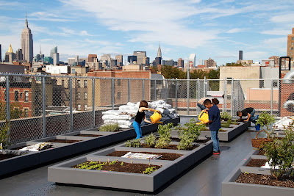
14. Does the school have a vegetable garden, flower garden or terrace garden?(Figure 5)

Figure 5: Cool for kids: Schools unveiling the new rooftop garden on the Robert Simon Complex, New York

15. How many trees and perennial shrubs were planted at the school this year? (Figure 6)

Figure 6: Springer school girls planting a fruit tree in Barbados
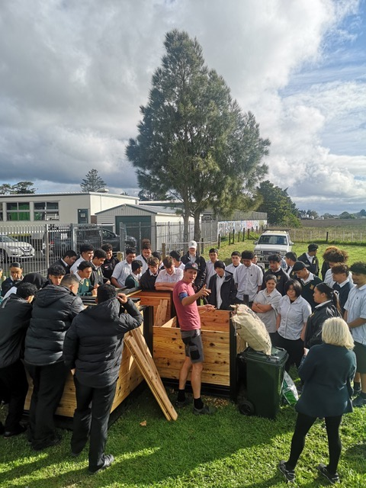
Figure 7: Installing a composter at Manurewa High School, New Zealand
16. Is composting done at school? (Figure 7)
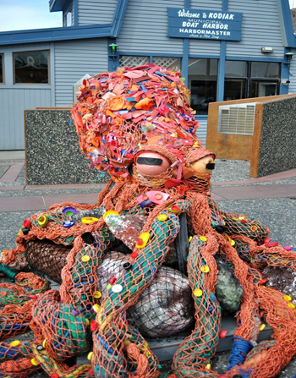
17. Are recyclable or waste materials used for student handicrafts at school? (Figure 8)

Figure 8: Octopus sculpture created by marine debris (Kodak High School, Alaska)

