ECB: Bought net €23.99 billion of assets last week vs. €28.67 billion previously
NEWS | 3/29/2021 1:54:01 PM GMT | By Eren Sengezer

The European Central Bank announced on Monday that it bought a net 23.995 billion euros of assets last week as part of its quantitative easing programme, compared to 28.672 billion euros a week earlier, per Reuters.

Additional details
"ECB sold a net 546 million euros of assets in covered bond purchase programme 3 in the week to March 26 vs 95 million euros week earlier."
"ECB bought a net 5.364 billion euros of assets in public sector purchase programme (QE) in the week to March 26 vs 5.449 billion euros week earlier."
"ECB bought a net 18.950 billion euros of Pandemic Emergency Purchase Programme (PEPP) bonds in week to March 26 vs 21.050 billion euros week earlier."
"ECB bought a net 334 million euros of corporate bonds in week to March 26 vs 2.136 billion euros week earlier."
"ECB sold a net 107 million euros of assets in asset-backed securities purchase programme in the week to march 26 vs sales of 58 million euros week earlier."

Market reaction
The EUR/USD pair edged modestly lower after this report and was last seen losing 0.12% on a daily basis at 1.1778.

Forex Today: Yields´ comeback may push the dollar to fresh highs
NEWS | 3/29/2021 8:05:50 PM GMT | By Valeria Bednarik

What you need to know on Tuesday, March 30:
Risk-off dominated Monday, leading to modest dollar gains. The greenback advanced within limited ranges against most major rivals. Investors are cautious at the start of the week amid news that a hedge fund that had significant positions in different firms was forced to liquidate late on Friday. Credit Suisse and Nomura reported significant losses as a result of the $20 billion block-sale.
Another point of concern is US President Joe Biden’s spending plan, which may include $1 trillion in new tax hikes. Major indexes in Europe and the US were under pressure, ending the day mixed. Meanwhile, US Treasury yields resumed their advances. The yield on the 10-year Treasury note hit 1.72%, its highest in over a week.
The EUR/USD pair set a fresh 2021 low of 1.1760, ending the day a handful of pips above the level. GBP/USD finished the day unchanged around 1.3770 after an early advance. The pound is still resilient to the dollar’s demand, partially underpinned by UK’s reopening as the coronavirus situation continues to improve.
Gold prices edged lower, undermined by rising US Treasury yields favoring the greenback. Crude oil prices advanced modestly after the Suez channel was finally freed.

EUR/USD still stuck below 1.1800, with euro plagued by pandemic concerns
NEWS | 3/29/2021 4:31:05 PM GMT | By Joel Frank

- EUR/USD has continued to struggle to get close to the 1.1800 level, with gains petering out around the 1.1790 area.
- Continued concerns about lockdown and the Coivd-19 pandemic in the Eurozone mean that it is unsurprising to EUR struggle.
EUR/USD has continued to struggle to get close to the 1.1800 level, with gains petering out around the 1.1790 area on Tuesday, but the price action remaining well support above last week’s 1.1760 lows. Rangebound trade is not really surprising given a lack of fresh fundamental drivers this Monday and with a batch of key events expected to shake things up later in the week. At present, the pair trades with modest losses of just over 10 pips or about 0.1% on the day.

Driving the day
Continued concerns about the lockdown and the trajectory of the pandemic in the Eurozone mean that it is unsurprising to see the euro struggle to gain traction against its US dollar counterpart on Monday. German Chancellor Angela Merkel reportedly does not see the lockdown restrictions in many states as sufficient to contain the third Covid-19 wave and is reportedly threatening to impose federal law to ensure restrictions are tough enough. Meanwhile, high infection rates in most EU countries mean lockdown eases remains a distant prospect for many countries.
But concerns that pre-mature reopening is driving what could be the start of the third wave of Covid-19 cases in the US (or that is how US NIH Director Anthony Fauci put it anyway) are growing. The US Centre for Disease Control and the White House have expressed concerns, and both are likely to put pressure on state governors not to reopen too fast or to even backtrack no some reopening measures. If the recent uptick in infections in the US does take a nasty turn, as happened in Europe over the last few weeks, then this could dent US growth expectations for 2021,which would in theory be USD negative. But USD may be able to fall back on its status as a safe-haven asset to save the day, at least versus the likes of the euro where the economic outlook will remain significantly worse even if there is a third wave in the US (mostly due to the lack of fiscal stimulus in Europe).
In other notable news for EUR/USD, the newest Fed member Chris Waller (who is a voter) gave his first speaking appearance. Waller noted that the Fed would respond to a disorderly rise in US government bond yields, but said that the recent rise in yields is not disorderly. Moreover, in a similar sentiment to other Fed members, Waller said that the recent move higher in yields is a reflection of the fact that the US economy is improving. He said that while Yields Curve Control is an available took for the Fed, “there are lots of tools you don’t need to pull out”. Finally, Waller noted that the Fed is a long way from raising rates.

EUR/Usd
Overview
Today last price | 1.1777
Today Daily Change | -0.0016
Today Daily Change % | -0.14
Today daily open | 1.1793

Trends
Daily SMA20 | 1.1924
Daily SMA50 | 1.2034
Daily SMA100 | 1.2057
Daily SMA200 | 1.1869

Levels
Previous Daily High | 1.1805
Previous Daily Low | 1.1764
Previous Weekly High | 1.1947
Previous Weekly Low | 1.1762
Previous Monthly High | 1.2243
Previous Monthly Low | 1.1952
Daily Fibonacci 38.2% | 1.1789
Daily Fibonacci 61.8% | 1.178
Daily Pivot Point S1 | 1.177
Daily Pivot Point S2 | 1.1746
Daily Pivot Point S3 | 1.1729
Daily Pivot Point R1 | 1.1811
Daily Pivot Point R2 | 1.1829
Daily Pivot Point R3 | 1.1852

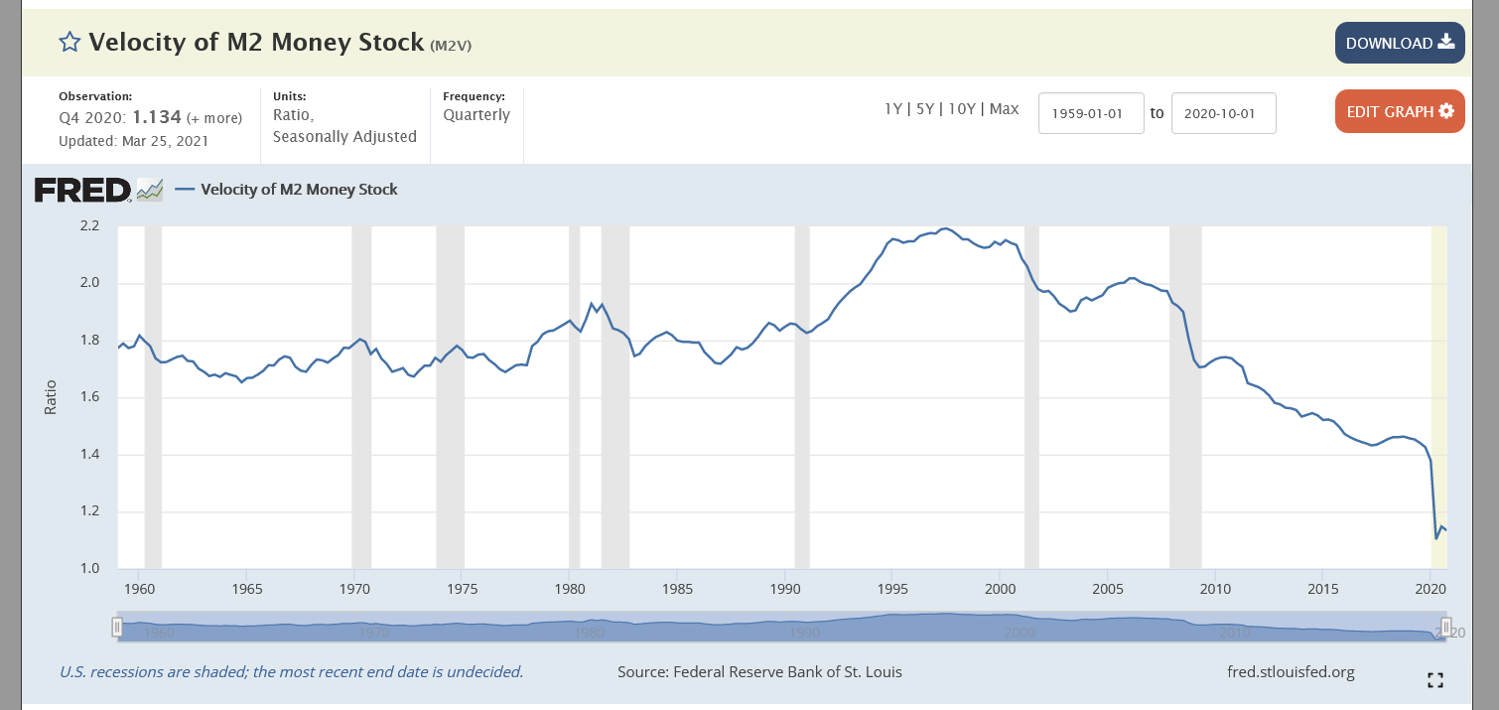
Units: Ratio, Seasonally Adjusted
Frequency: Quarterly
Calculated as the ratio of quarterly nominal GDP to the quarterly average of M2 money stock.
The velocity of money is the frequency at which one unit of currency is used to purchase domestically- produced goods and services within a given time period. In other words, it is the number of times one dollar is spent to buy goods and services per unit of time. If the velocity of money is increasing, then more transactions are occurring between individuals in an economy.
The frequency of currency exchange can be used to determine the velocity of a given component of the money supply, providing some insight into whether consumers and businesses are saving or spending their money. There are several components of the money supply,: M1, M2, and MZM (M3 is no longer tracked by the Federal Reserve); these components are arranged on a spectrum of narrowest to broadest. Consider M1, the narrowest component. M1 is the money supply of currency in circulation (notes and coins, traveler's checks [non-bank issuers], demand deposits, and checkable deposits). A decreasing velocity of M1 might indicate fewer short- term consumption transactions are taking place. We can think of shorter- term transactions as consumption we might make on an everyday basis.
Beginning May 2020, M2 consists of M1 plus (1) small-denomination time deposits (time deposits in amounts of less than $100,000) less IRA and Keogh balances at depository institutions; and (2) balances in retail MMFs less IRA and Keogh balances at MMFs. Seasonally adjusted M2 is constructed by summing savings deposits (before May 2020), small-denomination time deposits, and retail MMFs, each seasonally adjusted separately, and adding this result to seasonally adjusted M1. For more information on the H.6 release changes and the regulatory amendment that led to the creation of the other liquid deposits component and its inclusion in the M1 monetary aggregate, see the H.6 announcements and Technical Q&As posted on December 17, 2020.
MZM (money with zero maturity) is the broadest component and consists of the supply of financial assets redeemable at par on demand: notes and coins in circulation, traveler's checks (non-bank issuers), demand deposits, other checkable deposits, savings deposits, and all money market funds. The velocity of MZM helps determine how often financial assets are switching hands within the economy.
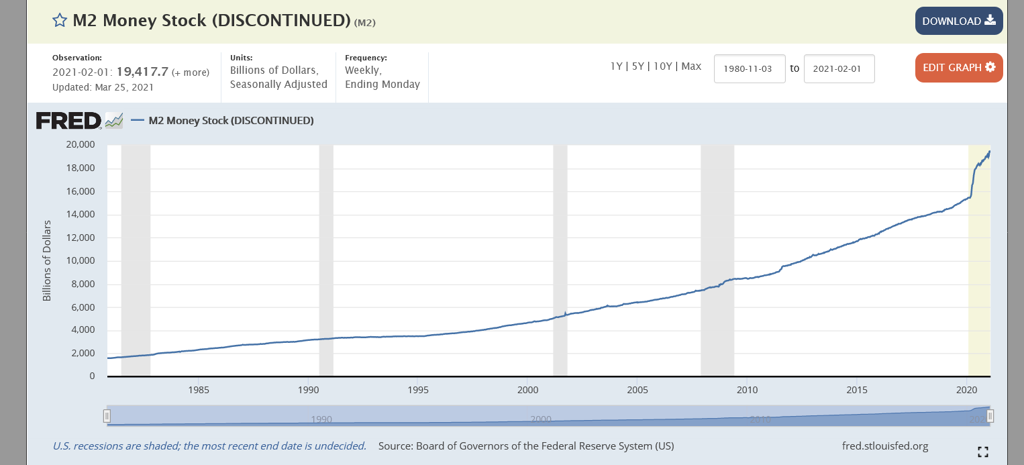
Units: Billions of Dollars, Seasonally Adjusted
Frequency: Weekly, Ending Monday
This weekly series is discontinued and will no longer be updated. The non-seasonally adjusted version of this weekly series is WM2NS, and the seasonally adjusted monthly series is M2SL.
Starting on February 23, 2021, the H.6 statistical release is now published at a monthly frequency and contains only monthly average data needed to construct the monetary aggregates. Weekly average, non-seasonally adjusted data will continue to be made available, while weekly average, seasonally adjusted data will no longer be provided. For further information about the changes to the H.6 Statistical Release, see the announcements provided by the source.
Before May 2020, M2 consists of M1 plus (1) savings deposits (including money market deposit accounts); (2) small-denomination time deposits (time deposits in amounts of less than $100,000) less individual retirement account (IRA) and Keogh balances at depository institutions; and (3) balances in retail money market funds (MMFs) less IRA and Keogh balances at MMFs.
Beginning May 2020, M2 consists of M1 plus (1) small-denomination time deposits (time deposits in amounts of less than $100,000) less IRA and Keogh balances at depository institutions; and (2) balances in retail MMFs less IRA and Keogh balances at MMFs. Seasonally adjusted M2 is constructed by summing savings deposits (before May 2020), small-denomination time deposits, and retail MMFs, each seasonally adjusted separately, and adding this result to seasonally adjusted M1. For more information on the H.6 release changes and the regulatory amendment that led to the creation of the other liquid deposits component and its inclusion in the M1 monetary aggregate, see the H.6 announcements and Technical Q&As posted on December 17, 2020.

Suggested Citation:
Board of Governors of the Federal Reserve System (US), M2 Money Stock (DISCONTINUED) [M2], retrieved from FRED, Federal Reserve Bank of St. Louis; https://fred.stlouisfed.org/series/M2, March 29, 2021.
