21/12/23

1)Read the passage carefully and do the T/F task that follows. Provide reasons to justify your answers.

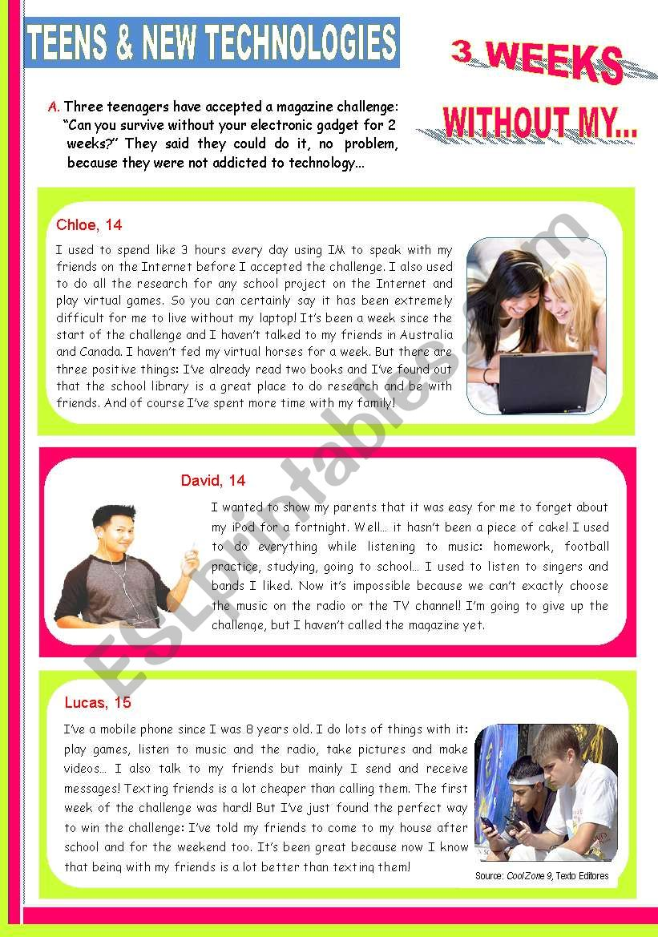
- Chloe struggles without her laptop.
- Chloe managed without her laptop for only 5 days.
- Chloe has strengthened her relationship with friends and family.
- David found the refraining from technology easy.
- David enjoys listening to music on the radio because he can come across interesting songs.
- David, at the end, admits defeat.
- Lucas bought his first phone at an early age.
- Lucas gives in to the lures of technology.
- Lucas admits that texting to friends is the same as meeting them.

https://www.eslprintables.com/vocabulary_worksheets/technologies/new_technologies/_Teens_and_New_Technologies__317771/

