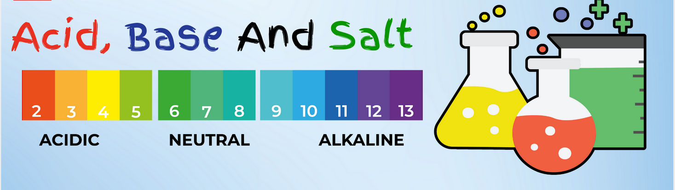
https://nextucate.com/acids-bases-and-salts-everyday-examples/

