Exploring Culinary Narratives:
Grammar Exercise 🍽️📚

Instructions: Read the following paragraphs about different culinary experiences around the world. Fill in the blanks with the appropriate form of the verbs: will/would, used to, can/could. 🌍🍽

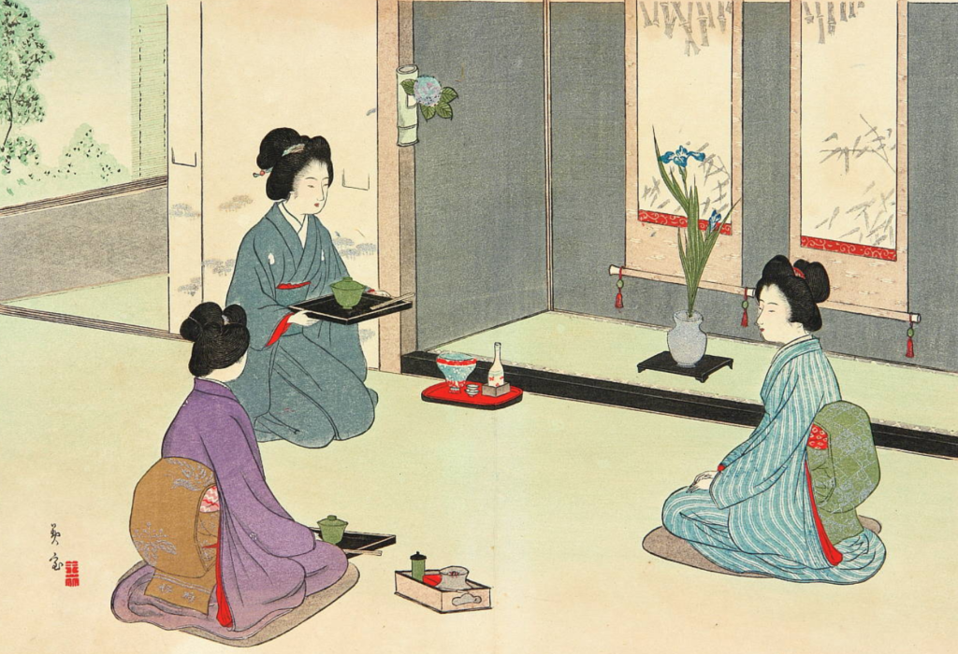
Japanese Tea Ceremony: In Japan, the traditional tea ceremony (1) _____ a highly ritualized event. Participants (2) _____ experience the meticulous preparation of matcha tea. The host (3) _____ gracefully present each step, and guests (4) _____ savor the moment. In the past, this ceremony (5) _____ a symbol of social status. 🎎🍵

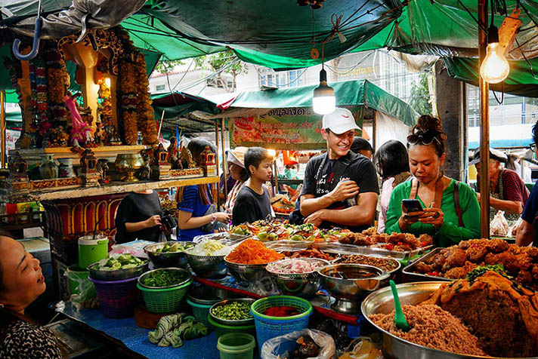
Street Food Adventures in Thailand: Exploring the vibrant street food scene in Thailand (6) _____ be an unforgettable experience. Stalls (7) _____ be found on every corner, offering a variety of delicious dishes. Locals (8) _____ tell you that these street foods (9) _____ an integral part of their daily lives. If you visit, you (10) _____ try the famous Pad Thai. 🌶️🥢

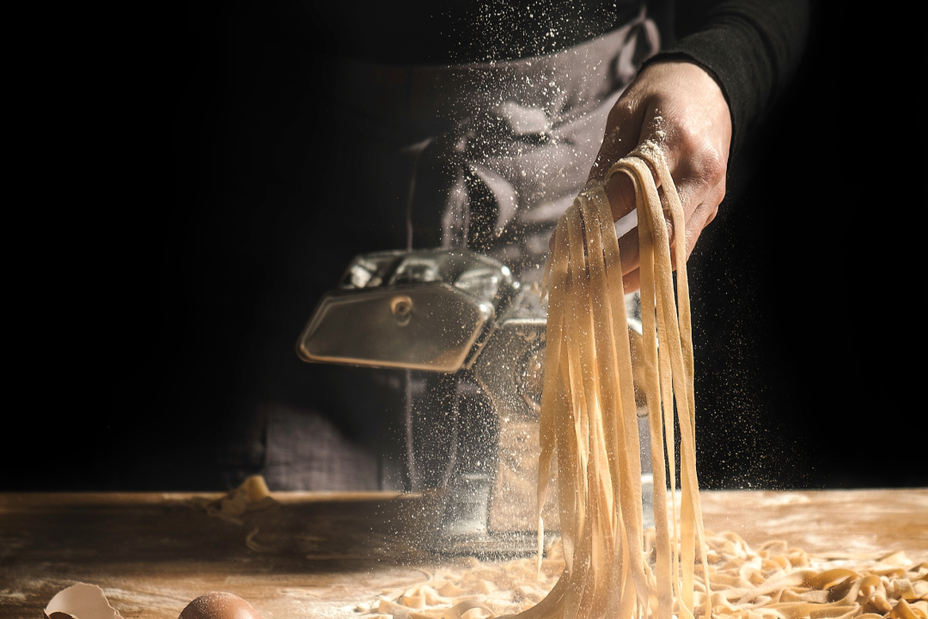
Italian Pasta-Making Tradition: In Italy, the art of making pasta by hand (11) _____ a skill passed down through generations. Families (12) _____ gather on Sundays to create a variety of pasta shapes. Nonna (grandmother) (13) _____ be the master of this craft, and she (14) _____ share her secrets with the younger ones. The aroma of homemade pasta (15) _____ transport you to an Italian kitchen. 🍝

Discussion: Discuss with a partner or the class:
- Share which culinary experience you find most interesting. 🤔🍜
- Discuss whether you have personally experienced any similar traditions. 🗣️👥
- Reflect on how food traditions connect to cultural practices. 🌐🌏 #CulinaryGrammar #LanguageExploration #CulturalConnections #FoodieTalks

