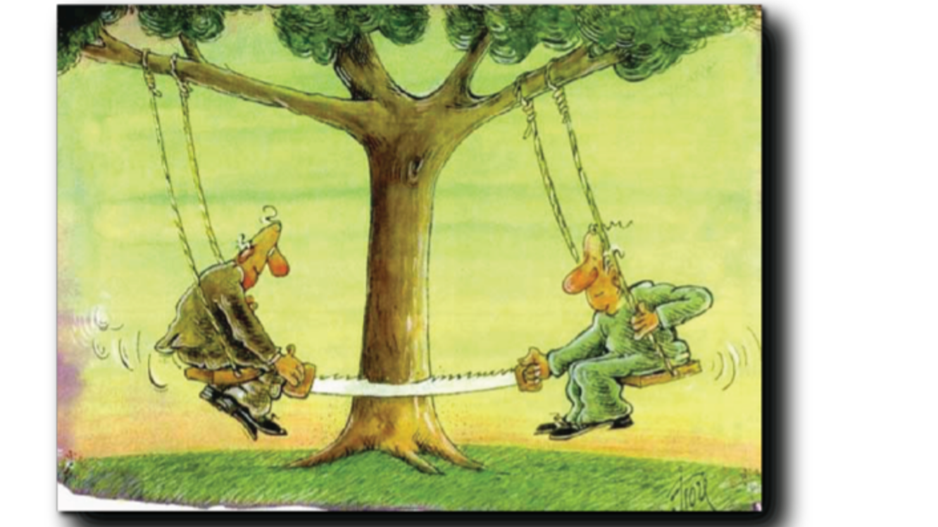

Aeiforia for the future
Sustainable Development (sustainability, aeiforia) was defined by the Brutland Commission Report "Our Common Future" in 1987 as "development that meets the needs of the present without compromising the ability of future generations to meet their own needs". Another definition states that Sustainable Development means "improving the quality of life by living within the framework of the carrying capacity of support systems". (The Global Conservation Strategy, Care for the Earth, 1990).
To put it more simply, Sustainability (aeiforia) is a desirable way to have both the dog full and the pie whole. That is, to take from the planet what we need, but not to destroy the systems of life support on the planet, so that future generations can live in dignity. In any case, the environment sets the boundaries.
So, we must see "how much we need." Desire is never satisfied, need is satisfied. What if we baptize our desires as needs? Well, then we are living in the current situation where seas, rivers and lakes are getting more and more polluted, the soil is poisoned, the rainforests (the DNA stores) are destroyed every day and those that are increasing are exhaust gases, poisons and psychiatric drugs.
Do You really want to let this situation go on?
N0, no, no…!

